British Association for
Sexual Health and HIV
Established 2003 through the merger of
MSSVD (est.1922) and AGUM (est.1992)

Charity number: 1148196 Company number: 7863350
VAT registration number: 859195278

Chester House, 68 Chestergate, Macclesfield, SK11 6DY
Tel: 01625 664523
Fax: 01625 664510
e-mail: admin@bashh.org
www.bashh.org



WESSEX BASHH REGIONAL CLINICAL NETWORK GROUP MULTIDISCIPLINARY MEETING
4th November 2024

Draft PROGRAMME *subject to change*

09:00 – 09:10 Welcome

09.10 – 09.30 Sponsors welcome (5 mins for each)

09.30– 10:20 Sustainability BASHH Sig representative Dr Thomas Pasvol Imperial College Healthcare NHS Trust

10:20 – 11:15 Chronic pain Alison Wickham specialist pain nurse Dorset Healthcare University Foundation Trust

11:15 – 11.30 Coffee

11:30 – 12.30 Complex Contraception case studies Dr Shruti Batham Dorset Healthcare University Foundation Trust

CLOSE

Meeting sponsored by MSD Ltd, Gilead, ViiV, and Kora

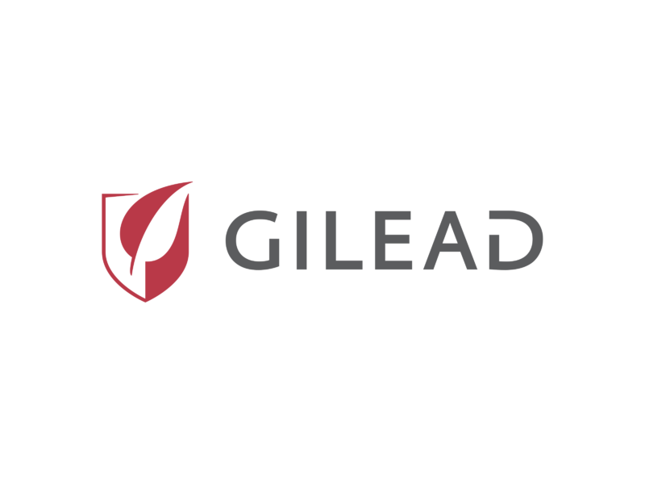




12:30 – 13:00 LUNCH

13:00 – 14:30 Clinical governance (Sangeetha Sundarum) open to BASHH members only

